SIMATS ENGINEERING

Department of Computer Science & Engineering
ASSESSMENT TOOL 2- PSEUDOCODE WRITING TASK (ALGORITHM DESIGN)

Course Code: | CSA12 | Course Title: | Computer Architecture
CO Assessed: | CO5 | Assessment: | ASSESSMENT TOOL2-  PSEUDOCODE WRITING TASK (ALGORITHM  DESIGN)
Weightage: | 30% | Total Marks: | 25
CO5 Statement: | Construct I/O communication mechanisms by comparing memory-mapped and I/O-mapped techniques, interrupt handling (vectored, hardware, software), DMA controllers, and advanced bus interfaces including PCIe, USB, NVMe, and Thunderbolt.
Student Name: | Kavinadhithya R S | Reg.No.: | 192511365
Department: | B tech CSE | Date: | 31/08/2026

ANNEXURE A

Pseudocode Writing Task (Algorithm Design)

- Write pseudocode to design a DMA-based data transfer algorithm that moves data from an I/O device to memory while handling interrupts and minimizing CPU involvement.
- Develop pseudocode for an interrupt handling system that prioritizes vectored interrupts from multiple devices and dispatches appropriate service routines.
- Write pseudocode to select between memory-mapped I/O and I/O-mapped I/O dynamically based on latency and bandwidth requirements.
- Design pseudocode for a bus arbitration algorithm that manages multiple devices communicating over PCIe, USB, and Thunderbolt interfaces.
- Write pseudocode to implement a hybrid I/O communication mechanism that uses polling for low-speed devices and DMA with interrupts for high-speed devices.

Code of Conduct:

I Kavinadhithya R S (192511365) (Name / Reg No) certify that this submission is my original work and that I have adhered to the guidelines specified for this assessment.
I understand that any violation of academic integrity rules will result in disciplinary action.

Signature of the student:

MARKS ALLOCATION

 | Problem Understanding  (20%) | Algorithm Design (30%) | Use of Control Structures (20%) | Pseudocode Structure (10%) | Completeness  (20%)
Q1
Q2
Q3
Q4
Q5

RUBRICS FOR CALCULATION:

Criteria | Weightag e | Level 4 – Exemplary | Level 3 – Proficient | Level 2 – Developing | Level 1 – Beginning
Problem Understanding | 20% | Identifies all inputs, outputs, constraints accurately | Minor missing elements | Partial understanding | Incorrect interpretation
Algorithm Design | 30% | Complete, correct, and logically sound solution | Minor logical gaps | Partially correct logic | Incorrect approach
Use of Control Structures | 20% | Efficient and appropriate use of loops, conditions, functions/modules | Minor inefficiencies | Limited or basic usage | Incorrect or missing constructs
Pseudocode Structure | 10% | Well-structured, clear, consistent format, easy to follow | Mostly clear with minor issues | Difficult to follow in parts | Poorly structured and unclear
Completeness | 20% | Handles all cases; optimized approach | Handles most cases; reasonable efficiency | Handles basic cases only | Incomplete or inefficient

Q1. Write pseudocode to design a DMA-based data transfer algorithm that moves data from an I/O device to memory while handling interrupts and minimizing CPU involvement.

Pseudocode
ALGORITHM DMA_Data_Transfer BEGIN
CPU receives request from I/O device

SET source = I/O_Device SET destination = Memory
SET data_size = required number of bytes

Configure DMA Controller with: source address
destination address data_size

Enable DMA transfer
CPU continues executing other tasks WHILE DMA transfer is not complete DO
CPU performs other operations END WHILE

WHEN DMA transfer is complete DO DMA Controller generates an interrupt
END WHEN INTERRUPT_HANDLER
Check DMA status

IF transfer completed successfully THEN Display "Data transferred successfully"
ELSE
Handle transfer error END IF

Clear interrupt
END INTERRUPT_HANDLER END
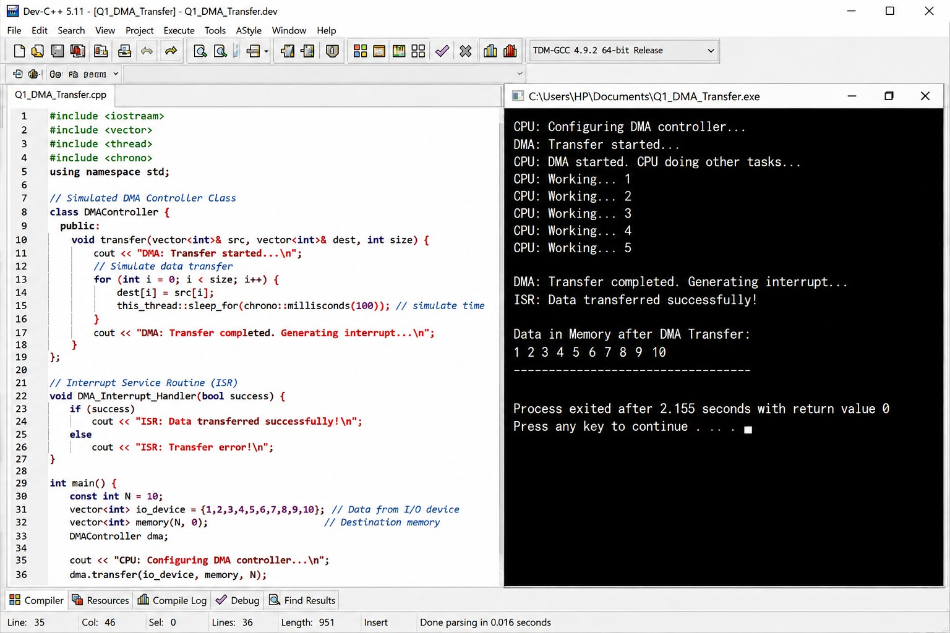

Explanation

The CPU only initializes the DMA controller.
- The DMA controller transfers data directly from the I/O device to memory.
- The CPU can perform other tasks during the transfer.
- After completion, DMA generates an interrupt to notify the CPU.

Q2. Develop pseudocode for an interrupt handling system that prioritizes vectored interrupts from multiple devices and dispatches appropriate service routines.

Pseudocode
ALGORITHM Priority_Interrupt_Handler BEGIN
WHILE system is running DO IF interrupt occurs THEN
Get interrupt vector number Determine priority of interrupt
IF interrupt priority is highest THEN

CALL appropriate Interrupt_Service_Routine ELSE
Place interrupt in priority queue END IF
END IF END WHILE
END

PROCEDURE Interrupt_Service_Routine(vector) SWITCH vector
CASE KEYBOARD_INTERRUPT:
CALL Keyboard_ISR

CASE MOUSE_INTERRUPT:
CALL Mouse_ISR

CASE DISK_INTERRUPT:
CALL Disk_ISR

CASE NETWORK_INTERRUPT:
CALL Network_ISR

DEFAULT:
CALL Default_ISR END SWITCH
Clear interrupt Return from interrupt
END PROCEDURE
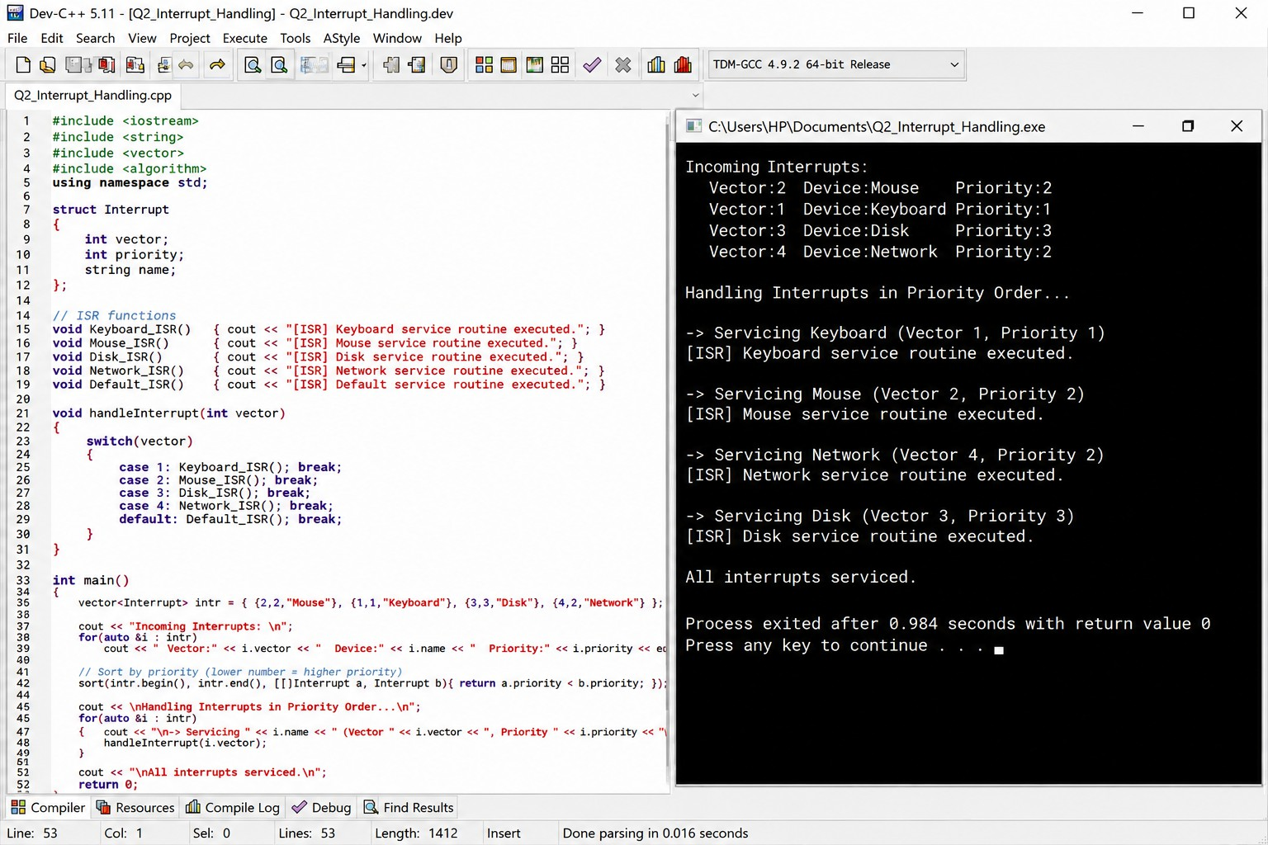

Explanation
- Each device generates an interrupt with a unique vector number.
- The system checks the priority of incoming interrupts.
- High-priority interrupts are serviced first.
- The vector number helps the CPU directly locate the correct Interrupt Service Routine (ISR).

Q3. Write pseudocode to select between memory-mapped I/O and I/O-mapped I/O dynamically based on latency and bandwidth requirements.

Pseudocode
ALGORITHM Select_IO_Method BEGIN
INPUT required_latency INPUT required_bandwidth

SET latency_threshold = LOW_LATENCY_LIMIT
SET bandwidth_threshold = HIGH_BANDWIDTH_LIMIT

IF required_latency <= latency_threshold AND required_bandwidth >= bandwidth_threshold THEN

SELECT Memory_Mapped_IO Display "Using Memory-Mapped I/O"
ELSE

SELECT IO_Mapped_IO Display "Using I/O-Mapped I/O"
END IF END

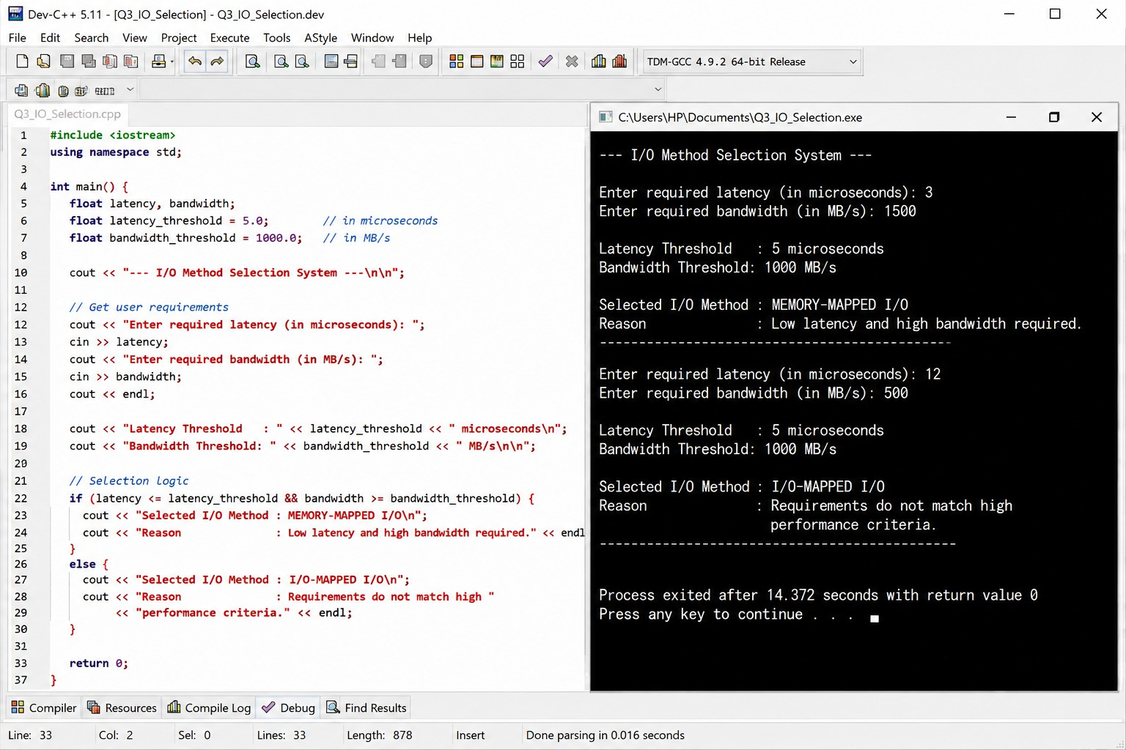

Explanation
- Memory-Mapped I/O is selected when fast access and high bandwidth are required.
- I/O-Mapped I/O is selected for devices where separate I/O instructions are suitable and performance requirements are lower.
- The decision is based on latency and bandwidth requirements.

Q4. Design pseudocode for a bus arbitration algorithm that manages multiple devices communicating over PCIe, USB, and Thunderbolt interfaces.

Pseudocode
ALGORITHM Bus_Arbitration BEGIN
Create request queue

WHILE system is running DO FOR each device DO
IF device requests bus access THEN Add device to request queue
END IF END FOR
IF request queue is not empty THEN Select highest priority device Grant bus access to selected device Identify interface type
IF interface = PCIe THEN Process PCIe communication

ELSE IF interface = USB THEN Process USB communication

ELSE IF interface = Thunderbolt THEN Process Thunderbolt communication

END IF

Wait until communication is complete

Release bus

Remove device from request queue END IF
END WHILE

END
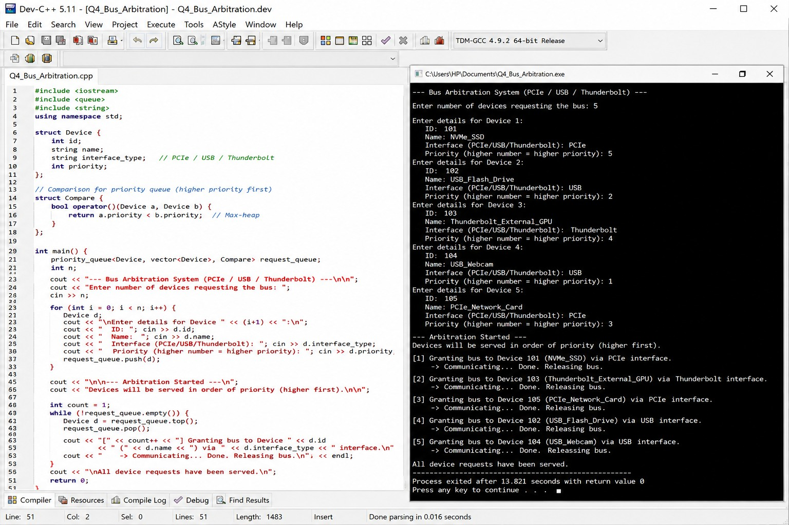

Explanation
- Devices request access to the communication bus.
- Requests are stored in a queue.
- The bus arbiter selects a device based on priority.
- Communication is handled according to the interface:
  - PCIe

USB

Thunderbolt
- After completion, the bus is released for the next device.

Q5. Write pseudocode to implement a hybrid I/O communication mechanism that uses polling for low-speed devices and DMA with interrupts for high-speed devices.

Pseudocode
ALGORITHM Hybrid_IO_Communication BEGIN
FOR each I/O device DO Get device speed
IF device speed is LOW THEN Display "Using Polling" WHILE device is active DO
Check device status

IF data is available THEN

Read data from device Process data

END IF END WHILE

ELSE IF device speed is HIGH THEN Display "Using DMA with Interrupts" Configure DMA Controller
Start DMA transfer

CPU performs other tasks

WHEN DMA transfer is complete DO

Generate interrupt END WHEN
INTERRUPT_HANDLER

Check transfer status

IF transfer successful THEN Process received data
ELSE
Handle error END IF

Clear interrupt

END INTERRUPT_HANDLER END IF
END FOR END

Explanation
This hybrid mechanism chooses the best communication method based on device speed:

Device Type | Communication Method
Low-speed device | Polling
High-speed device | DMA + Interrupts
- Polling is simple and suitable for low-speed devices.
- DMA reduces CPU involvement during large, high-speed transfers.
- Interrupts notify the CPU only when the DMA operation is complete.




